Benita Chinemerem   
Data Analytics Fall 24 Lab 5

SVM Classification (Wine)

Best parameters for linear SVM

cost

3 1  
  
Best parameters for radial SVM

gamma cost

49 0.0625 4  
  
  
  
Linear SVM Performance

Accuracy: 9.615385e-01  
Kappa: 9.415402e-01  
AccuracyLower: 8.678716e-01  
AccuracyUpper: 9.953077e-01  
AccuracyNull : 4.038462e-01  
AccuracyPValue : 9.898988e-18  
McnemarPValue : NaN  
  
  
Linear SVM Performance (Class)  
  
Sensitivity Specificity Pos Pred Value Neg Pred Value Precision Recall F1 Prevalence

Class: 1 1.0000000 0.9428571 0.8947368 1.000000 0.8947368 1.0000000 0.9444444 0.3269231

Class: 2 0.9523810 1.0000000 1.0000000 0.968750 1.0000000 0.9523810 0.9756098 0.4038462

Class: 3 0.9285714 1.0000000 1.0000000 0.974359 1.0000000 0.9285714 0.9629630 0.2692308

Detection Rate Detection Prevalence Balanced Accuracy

Class: 1 0.3269231 0.3653846 0.9714286

Class: 2 0.3846154 0.3846154 0.9761905

Class: 3 0.2500000 0.2500000 0.9642857  
  
  
  
  
  
  
Radial SVM Performance

Accuracy: 9.807692e-01  
Kappa: 9.708193e-01  
AccuracyLower: 8.974465e-01  
AccuracyUpper: 9.995132e-01  
AccuracyNull : 4.038462e-01  
AccuracyPValue : 2.594158e-19  
McnemarPValue : NaN  
  
  
Radial SVM Performance (Class)  
  
Sensitivity Specificity Pos Pred Value Neg Pred Value Precision Recall F1 Prevalence

Class: 1 1.000000 0.9714286 0.9444444 1.00000 0.9444444 1.000000 0.9714286 0.3269231

Class: 2 0.952381 1.0000000 1.0000000 0.96875 1.0000000 0.952381 0.9756098 0.4038462

Class: 3 1.000000 1.0000000 1.0000000 1.00000 1.0000000 1.000000 1.0000000 0.2692308

Detection Rate Detection Prevalence Balanced Accuracy

Class: 1 0.3269231 0.3461538 0.9857143

Class: 2 0.3846154 0.3846154 0.9761905

Class: 3 0.2692308 0.2692308 1.0000000

Using a classification method (kNN) to train a classifier based on the same features.  
  
Best k value; 9  
  
kNN performance   
  
Accuracy: 9.807692e-01

Kappa: 9.707042e-01

AccuracyLower: 8.974465e-01

AccuracyUpper: 9.995132e-01

AccuracyNull : 4.038462e-01

AccuracyPValue : 2.594158e-19

McnemarPValue : NaN  
  
  
  
kNN Performance (Class)

Sensitivity Specificity Pos Pred Value Neg Pred Value Precision Recall F1 Prevalence

Class: 1 1.0000000 0.9714286 0.9444444 1.000000 0.9444444 1.0000000 0.9714286 0.3269231

Class: 2 1.0000000 1.0000000 1.0000000 1.000000 1.0000000 1.0000000 1.0000000 0.4038462

Class: 3 0.9285714 1.0000000 1.0000000 0.974359 1.0000000 0.9285714 0.9629630 0.2692308

Detection Rate Detection Prevalence Balanced Accuracy

Class: 1 0.3269231 0.3461538 0.9857143

Class: 2 0.4038462 0.4038462 1.0000000

Class: 3 0.2500000 0.2500000 0.9642857

k selection for kNN  
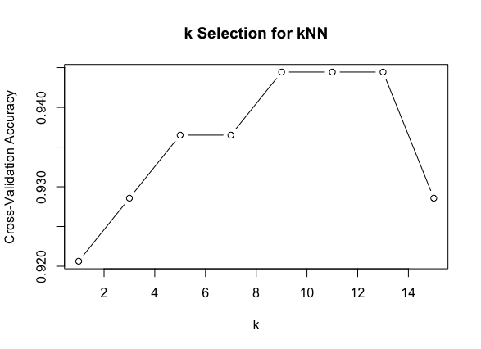

Comparison of performance of the 2 models (Precision, Recall, F1)

Confusion Matrix of the Linear SVM   
  
 Reference

Prediction 1 2 3

1 17 1 1

2 0 20 0

3 0 0 13  
  
Confusion Matrix of the Radial SVM   
  
 Reference

Prediction 1 2 3

1 17 1 1

2 0 20 0

3 0 0 14

Confusion Matrix of the kNN   
  
 Reference

Prediction 1 2 3

1 17 1 1

2 0 20 0

3 0 0 14

Comparison of the models  
  
 Model Precision Recall F1_Score

1 Linear SVM 0.8947368 1.0000000 0.9444444

2 Radial SVM 1.0000000 0.9523810 0.9756098

3 kNN 1.0000000 0.9285714 0.9629630

4 Linear SVM 0.9444444 1.0000000 0.9714286

5 Radial SVM 1.0000000 0.9523810 0.9756098

6 kNN 1.0000000 1.0000000 1.0000000

7 Linear SVM 0.9444444 1.0000000 0.9714286

8 Radial SVM 1.0000000 0.9523810 0.9756098

9 kNN 1.0000000 1.0000000 1.0000000

SVM (New York Housing)

SVM  
Mean Squared Error: 29016258975766.8

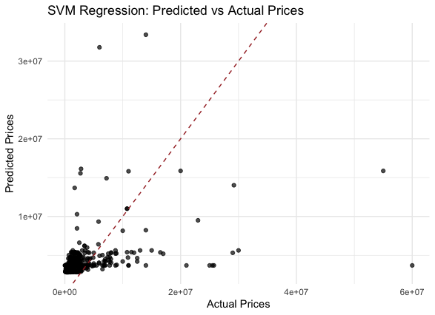

LM  
Mean Squared Error: 29016258975766.8

